Intermolecular Forces and Their Effect on Physical Properties

Why does water boil at 100°C while acetone boils at only 56°C? Why does water form beads on a waxy surface while ethanol spreads out? Why does honey flow slowly while acetone evaporates quickly? These differences are not explained by the atoms inside the molecules alone. They are explained by the forces between molecules — the intermolecular forces of attraction. These forces are much weaker than the chemical bonds that hold atoms together within a molecule, but they have a profound effect on the physical properties of substances: boiling point, viscosity, surface tension, vapor pressure, and molar heat of vaporization. Understanding intermolecular forces allows chemists to predict how substances will behave and to explain why water is uniquely suited to support life.
This reading material uses a diagram to differentiate intermolecular forces from intramolecular forces in liquid water. It uses secondary sources to explain the effect of intermolecular forces on liquid properties such as surface tension, viscosity, vapor pressure, boiling point, and molar heat of vaporization. Finally, it uses a table to compare the intermolecular forces of attraction and properties of water, acetone, and ethanol.

Part 1: Intramolecular vs. Intermolecular Forces

What Are Intramolecular Forces?
Intramolecular forces are the forces that hold atoms together within a molecule. These are chemical bonds — covalent, ionic, or metallic. They determine the chemical identity of the substance. Breaking them requires a chemical reaction and a large amount of energy.
Type of Intramolecular Force | Description | Example
Covalent bond | Sharing of electrons between nonmetal atoms | O–H bonds in water
Ionic bond | Transfer of electrons between metal and nonmetal | Na⁺Cl⁻ in sodium chloride
Metallic bond | Sharing of electrons among metal atoms | Fe–Fe bonds in iron

What Are Intermolecular Forces?
Intermolecular forces (IMFA) are the forces of attraction between molecules. They are much weaker than intramolecular forces — typically 1–10% as strong as a covalent bond. They determine the physical properties of a substance: boiling point, melting point, viscosity, surface tension, vapor pressure, and molar heat of vaporization.
Type of Intermolecular Force | Description | Strength (kJ/mol)
London dispersion forces | Temporary dipoles caused by electron movement; present in all molecules | 0.05–40
Dipole-dipole forces | Attraction between permanent dipoles of polar molecules | 5–25
Hydrogen bonds | Strong dipole-dipole attraction when H is bonded to N, O, or F | 10–40
Ion-dipole forces | Attraction between an ion and a polar molecule | 40–600

Diagram: Intramolecular vs. Intermolecular Forces in Liquid Water
The diagram below shows liquid water. The solid lines represent intramolecular forces (covalent O–H bonds within each water molecule). The dotted line represents the intermolecular force (hydrogen bond) between water molecules.

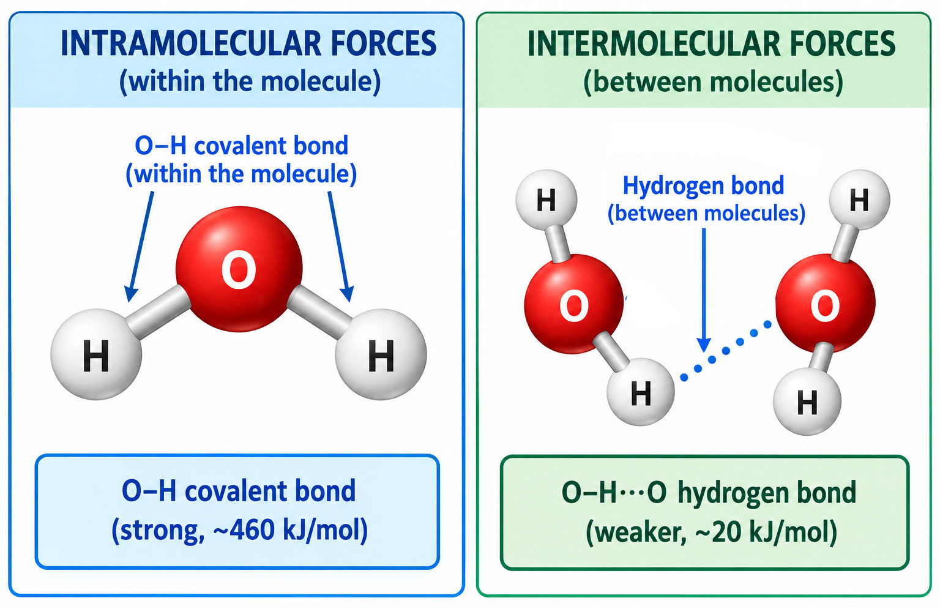

How to interpret the diagram:
Feature | Intramolecular Force | Intermolecular Force
What it holds together | Atoms within a molecule | Separate molecules
Bond type | Covalent bond | Hydrogen bond
Strength | Strong (~460 kJ/mol) | Weak (~20 kJ/mol)
What it determines | Chemical identity | Physical properties
What breaks it | Chemical reaction | Heating, evaporation
Key insight: When water boils, the intermolecular forces (hydrogen bonds) break, allowing molecules to escape as gas. The intramolecular forces (O–H covalent bonds) do not break. The water molecule remains intact as H₂O in the vapor phase.

Part 2: Effect of Intermolecular Forces on Liquid Properties

1. Surface Tension
Surface tension is the energy required to increase the surface area of a liquid. It is caused by the unbalanced forces on molecules at the surface.
Factor | Explanation
What happens at the surface | Surface molecules are pulled inward and sideways by IMFA but have no molecules above them to pull upward
Result | The surface acts like a stretched elastic film
Effect of IMFA strength | Stronger IMFA → higher surface tension
Example | Water has high surface tension (72 mN/m) due to hydrogen bonds; it forms beads and supports small insects

2. Viscosity
Viscosity is a liquid's resistance to flow. It measures how easily molecules slide past one another.
Factor | Explanation
What causes resistance | Molecules with strong IMFA resist sliding past each other
Effect of IMFA strength | Stronger IMFA → higher viscosity
Effect of molecular size | Larger molecules → higher viscosity (more entanglement)
Example | Honey (strong IMFA and large molecules) flows slowly; acetone (weak IMFA and small molecules) flows quickly

3. Vapor Pressure
Vapor pressure is the pressure exerted by a vapor in equilibrium with its liquid at a given temperature.
Factor | Explanation
What causes vapor pressure | Molecules at the surface escape into the gas phase
Effect of IMFA strength | Stronger IMFA → lower vapor pressure (molecules are held more tightly)
Effect of temperature | Higher temperature → higher vapor pressure
Example | Acetone (weak IMFA) has high vapor pressure and evaporates quickly; water (strong IMFA) has lower vapor pressure

4. Boiling Point
Boiling point is the temperature at which a liquid's vapor pressure equals atmospheric pressure.
Factor | Explanation
What boiling requires | Enough energy to overcome IMFA and allow molecules to escape
Effect of IMFA strength | Stronger IMFA → higher boiling point
Effect of molecular size | Larger molecules → higher boiling point (more electrons = stronger dispersion forces)
Example | Water (hydrogen bonds) boils at 100°C; acetone (dipole-dipole) boils at 56°C

5. Molar Heat of Vaporization
Molar heat of vaporization (ΔHvap) is the energy required to vaporize one mole of a liquid at its boiling point.
Factor | Explanation
What it measures | Energy needed to overcome IMFA completely
Effect of IMFA strength | Stronger IMFA → higher molar heat of vaporization

Example | Water has a high ΔHvap (40.65 kJ/mol) because hydrogen bonds must be broken; acetone has a lower ΔHvap (31.3 kJ/mol) because dipole-dipole forces are weaker

Summary Table: Effect of IMFA Strength on Properties
Property | Stronger IMFA | Weaker IMFA
Surface tension | Higher | Lower
Viscosity | Higher | Lower
Vapor pressure | Lower | Higher
Boiling point | Higher | Lower
Molar heat of vaporization | Higher | Lower

Why This Matters
Application | How IMFA Explains It
Water's high boiling point | Allows liquid water to exist on Earth
Water's high heat of vaporization | Allows sweating to cool the body
Water's high surface tension | Allows capillary action in plants
Acetone's quick evaporation | Makes it useful as a solvent and nail polish remover
Ethanol's intermediate properties | Makes it useful as a solvent and fuel additive

Part 3: Comparison of Water, Acetone, and Ethanol

Structures and Intermolecular Forces
Substance | Formula | Structure | Polarity | Types of IMFA Present | Strongest IMFA
Water | H₂O | Bent | Polar | Hydrogen bonds, dipole-dipole, London dispersion | Hydrogen bonds
Acetone | C₃H₆O (CH₃COCH₃) | Trigonal planar at C=O | Polar | Dipole-dipole, London dispersion | Dipole-dipole
Ethanol | C₂H₅OH (CH₃CH₂OH) | Tetrahe-dral at C | Polar | Hydrogen bonds, dipole-dipole, London dispersion | Hydrogen bonds
Note: Acetone cannot form hydrogen bonds with itself because it has no O–H bond. It can only accept hydrogen bonds from other molecules. This is why its IMFA are weaker than water's or ethanol's.

Comparison Table: Properties of Water, Acetone, and Ethanol
Property | Water (H₂O) | Acetone (C₃H₆O) | Ethanol (C₂H₅OH)
Molar mass (g/mol) | 18.02 | 58.08 | 46.07
Strongest IMFA | Hydrogen bonds | Dipole-dipole | Hydrogen bonds
Boiling point (°C) | 100.0 | 56.1 | 78.4
Viscosity (mPa·s at 25°C) | 0.89 | 0.31 | 1.07
Surface tension (mN/m at 25°C) | 72.0 | 23.7 | 22.4
Vapor pressure (kPa at 25°C) | 3.17 | 30.8 | 7.9
Molar heat of vaporization (kJ/mol) | 40.65 | 31.3 | 38.56

Analysis of the Data
Observation | Explanation
Water has the highest boiling point | Water has the strongest IMFA (hydrogen bonds in a 3D network)
Acetone has the lowest boiling point | Acetone has the weakest IMFA (dipole-dipole only)
Water has the highest surface tension | Water's hydrogen bonding network creates strong cohesive forces at the surface
Ethanol and acetone have similar surface tension | Both have weaker IMFA at the surface compared to water
Water has the highest molar heat of vaporization | More energy is needed to break water's extensive hydrogen bonding network
Acetone has the highest vapor pressure | Weak IMFA means molecules escape easily into the gas phase
Ethanol has the highest viscosity | Larger molecules and hydrogen bonding create resistance to flow

Why Water Is Unique
Property | Value | Why It Matters
Boiling point | 100°C | Allows liquid water to exist on Earth
Heat of vaporization | 40.65 kJ/mol | Allows sweating to cool the body
Surface tension | 72 mN/m | Allows capillary action in plants
Specific heat capacity | 4.18 J/g°C | Stabilizes Earth's climate

Key Terms
Term | Definition
Intramolecular force | Force that holds atoms together within a molecule (covalent, ionic, metallic bond)
Intermolecular force (IMFA) | Force of attraction between molecules
London dispersion force | Weak IMFA caused by temporary dipoles; present in all molecules
Dipole-dipole force | IMFA between permanent dipoles of polar molecules
Hydrogen bond | Strong dipole-dipole attraction when H is bonded to N, O, or F
Surface tension | Energy required to increase the surface area of a liquid
Viscosity | A liquid's resistance to flow
Vapor pressure | Pressure exerted by a vapor in equilibrium with its liquid
Boiling point | Temperature at which vapor pressure equals atmospheric pressure
Molar heat of vaporization | Energy required to vaporize one mole of a liquid at its boiling point

Review Questions
1. Differentiate intramolecular forces from intermolecular forces. Provide two examples of each.
2. Using the diagram of liquid water, explain the difference between the O–H covalent bond and the hydrogen bond between water molecules.
3. Explain how intermolecular forces affect each of the following properties:
- (a) Surface tension
- (b) Viscosity
- (c) Vapor pressure
- (d) Boiling point
- (e) Molar heat of vaporization
4. Complete the following table comparing water, acetone, and ethanol:
Property | Water | Acetone | Ethanol
Strongest IMFA
Boiling point (°C)
Viscosity (mPa·s)
Surface tension (mN/m)
Vapor pressure (kPa)
Molar heat of vaporization (kJ/mol)
5. Explain why acetone has a lower boiling point than water. Use the concept of intermolecular forces in your answer.

6. Explain why ethanol has a higher viscosity than acetone even though both have similar surface tension.
7. Why is water's high molar heat of vaporization important for living organisms?
8. Pag-aralan ang sitwasyon sa ibaba at sagutin ang mga tanong.
A student spills water and acetone on a laboratory table. Both are at room temperature (25°C). The student notices that the acetone evaporates much faster than the water.
- (a) Which substance has the higher vapor pressure? Explain.
- (b) Which substance has the stronger intermolecular forces? Explain.
- (c) Predict which substance has the higher boiling point. Explain your reasoning.
9. Using secondary sources, write a short explanation (3–5 sentences) of how intermolecular forces affect the boiling point, viscosity, and surface tension of liquids.
10. Application question: A chemist needs to choose a solvent for a reaction that requires a liquid with a high boiling point and low vapor pressure. Between water, acetone, and ethanol, which would be the best choice? Explain your answer using the data from the comparison table.

Answers
1. Intramolecular forces hold atoms together within a molecule (e.g., O–H covalent bond in water, Na–Cl ionic bond in salt). Intermolecular forces attract separate molecules to each other (e.g., hydrogen bonds between water molecules, dipole-dipole forces between acetone molecules).
2. The O–H covalent bond is an intramolecular force that holds the hydrogen atom to the oxygen atom within a single water molecule. It is strong (~460 kJ/mol) and requires a chemical reaction to break. The hydrogen bond is an intermolecular force that attracts the hydrogen of one water molecule to the oxygen of another. It is weaker (~20 kJ/mol); and breaks when water boils.
3.
(a) Stronger IMFA → higher surface tension.
(b) Stronger IMFA → higher viscosity.
(c) Stronger IMFA → lower vapor pressure.
(d) Stronger IMFA → higher boiling point.
(e) Stronger IMFA → higher molar heat of vaporization.
4.
Property | Water | Acetone | Ethanol
Strongest IMFA | Hydrogen bonds | Dipole-dipole | Hydrogen bonds
Boiling point (°C) | 100.0 | 56.1 | 78.4
Viscosity (mPa·s) | 0.89 | 0.31 | 1.07
Surface tension (mN/m) | 72.0 | 23.7 | 22.4
Vapor pressure (kPa) | 3.17 | 30.8 | 7.9
Molar heat of vaporization (kJ/mol) | 40.65 | 31.3 | 38.56
5. Acetone has only dipole-dipole forces, while water has hydrogen bonds. Hydrogen bonds are stronger than dipole-dipole forces, so more energy is required to break them and allow water molecules to escape as gas. This is why water boils at 100°C while acetone boils at 56°C.
6. Ethanol has a higher viscosity because its molecules are larger and can form hydrogen bonds. Acetone has smaller molecules and only dipole-dipole forces. Viscosity depends on both molecular size and IMFA strength, so ethanol's larger size and hydrogen bonding create more resistance to flow.

7. Water's high molar heat of vaporization means that a large amount of energy is required to convert liquid water to vapor. This is important for living organisms because sweating removes a large amount of heat from the body, helping to regulate temperature.
8.
(a) Acetone has the higher vapor pressure because it has weaker intermolecular forces, allowing molecules to escape into the gas phase more easily.
(b) Water has the stronger intermolecular forces because it has hydrogen bonds, while acetone has only dipole-dipole forces.
(c) Water has the higher boiling point because stronger intermolecular forces require more energy to overcome.
9. Intermolecular forces determine the physical properties of liquids. Stronger IMFA result in higher boiling points, higher viscosity, and higher surface tension. This is because more energy is required to overcome the attractive forces between molecules. For example, water has strong hydrogen bonds, giving it a high boiling point, high surface tension, and high viscosity compared to acetone, which has weaker dipole-dipole forces.
10. Water would be the best choice because it has the highest boiling point (100°C) and the lowest vapor pressure (3.17 kPa) among the three liquids. Its strong hydrogen bonds make it resistant to evaporation and require high energy to boil. Acetone has a low boiling point and high vapor pressure, making it unsuitable. Ethanol has intermediate properties but still lower boiling point and higher vapor pressure than water.

